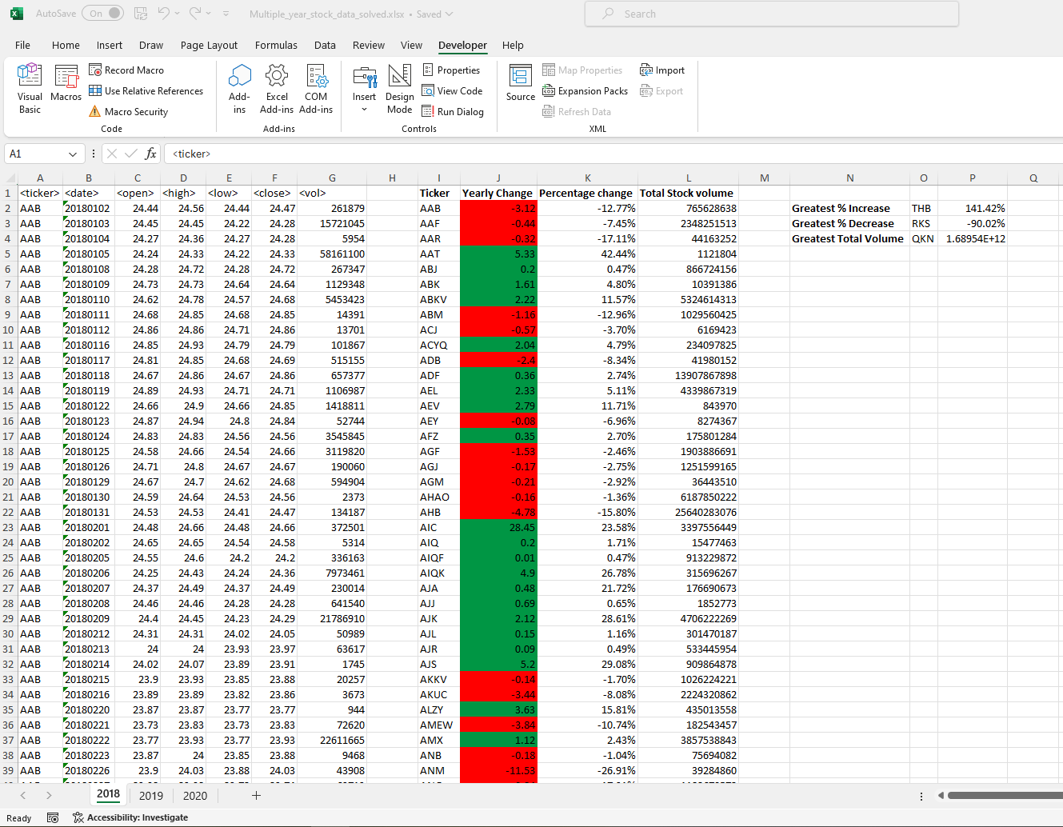Year: 2018 – Beginning and End of summary table

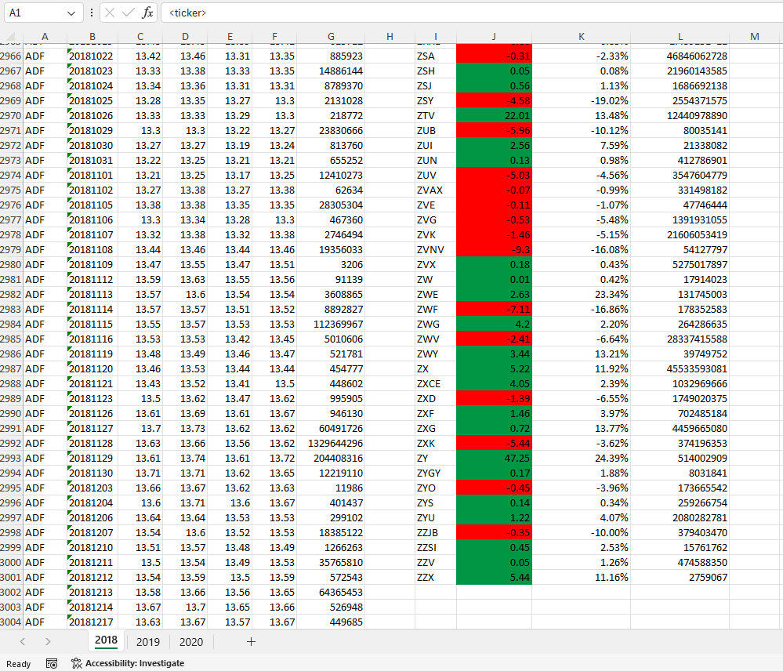

Year: 2019 – Beginning and End of summary table

Year: 2020 – Beginning and End of summary table

